Use Case Realisation Report (Analysis) - Manage Project InterestManage project interest
FOR
Volunteer Management System
(VMS)

CLIENT
PROJECT | Volunteer Management System (VMS)Volunteer Management System
TITLE | Use Case Realisation Report (Analysis) - Manage Project Interest
VERSION | 0.2a
DATE | 13-Aug-2011
 | ORIGINATOR
 | Name / Signature | Team 8S
 | APPROVAL
 | Name / Signature | Phung Kim Cuong, Dio
Institute of Systems Science |  | Document Reference
25 Heng Mui Keng Terrence  Singapore 119615 |  | VMS/T-1.4.1/1

 | Acceptance
 | Customer Signature |  | Customer Signature
 | Name & Designation |  | Name & Designation
 | Date & Company Stamp |  | Date & Company Stamp

Revision History

Date | Version | Description | Author
12-Jun-2011 | 0.1a | Creation | Team 8S
12-Aug-2011 | 0.2a | Updates | Team 8S

Table of Contents

1. Brief Description 3
2. Flow of Events 3
2.1 Standard Flow 3
2.2 Exceptions 4
3. Interaction Diagrams 4
3.1 Collaboration Diagram: Manage Project Interest 4
4. Participating Objects 5
4.1 HomeScreen 5
4.2 MainController 5
4.3 Volunteer 5
5. Class Diagram 5
6. Derived Requirements 6
ANNEX D Amendment History 6

Use-Case Realization Report (Analysis) -Manage Project Interest

Brief Description
The use case enables registered user with project manager view the project interest and reply the project interest by accepting or rejecting the project interest raised by the volunteer. If a volunteer’s project interest is accepted by the project manage, that volunteer will become a project member.

Flow of Events
The standard flow of events for this use case and any exceptions are described in the following subsections. See section 3 for an overview of the participating Actors and Domain Objects.

Standard Flow

Precondition: Project Manager has logged in the system and use case 4.6 has been executed

This use case provides the user interface related functionality that will be provided to the User, as follows:
The use case starts when the project manager selects the Manage Project Interest option from the HomeScreen user interface. The HomeScreen.manageProjectInterest() method is triggered.
- The MenuScreen.manageProjectInterest() triggers the MainController. manageProjectInterest() operation which delegates to ViewProjectInterestScreen. show().
- The show() launches the user interface ViewProjectInterestScreen.
- The project manager uses the ViewProjectInterestScreen user interface to select or key in the project criteria like the project name. When the project manager clicks the Search button in the screen, ViewProjectInterestScreen.enterSearchCriteria() is called.
- The enterSearchCriteria () will triggers the ProjectInterestController.processSearch() to retrieve the list of the project interest that match the criteria.
- The ProjectInterestController.processSearch() will triggers the ProjectFeedback.findProjectInterest() operation to retrieve the list of the project interest that match the criteria.
- After that, ProjectInterestController triggers the ViewProjectInterestScreen.displayResult() operation to display the list of the matching project interest.
- The ViewProjectInterestScreen.displayResult() operation will also triggers the ProjectInterest.getProjectInterest() operation to retrieves the project feedback records.
- The project manager can update the status of each project interest raised by volunteers and click Update button in the ViewProjectInterestScreen screen. ViewProjectInterestScreen.acceptRejectProjectInterest() operation is called.
- The acceptRejectProjectInterest() will triggers the ProjectInterestController.updateProjectInterestStatus() to update the status of the project interests.
- After that, ProjectInterestController triggers the ProjectInterest.updateProjectInterestStatus() operation to update the status of the project interest request.
- ProjectInterestController will triggers the ProjectInterest.getProjectInterestStatus() and Volunteer.getVolunteer() operations to populate the email context.
- ProjectInterestController triggers the EmailServiceController.sendEmail() operation to notify the result of the project interest to the requested volunteers.
- The use case terminates when the project manager click the Close button of the ViewProjectInterestScreen.

Exceptions
The following exceptions have been identified:

- There is no matching project interest: if there is no matching Project Interest for the selected project, the ProjectInterestController will return empty list of Project Interest passing in the displayResult() and the ViewProjectInterestScreen will show an empty list with the “No project interest found” message.

Interaction Diagrams

Collaboration Diagram: Manage Project Interest

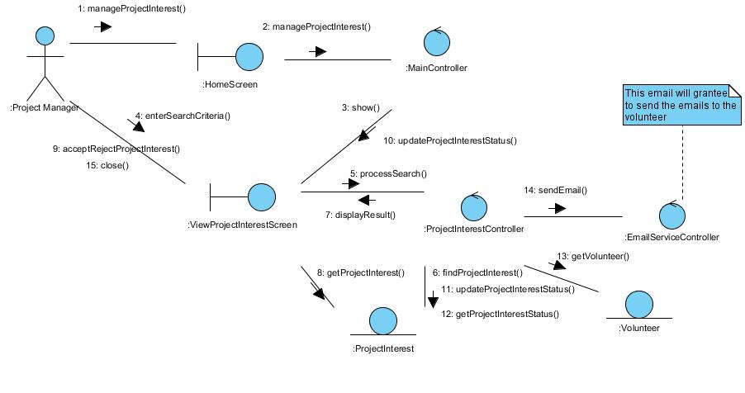
Figure 1 - Collaboration Diagram for View Project Interest

Participating Objects

HomeScreen
This boundary object is used for redirecting and displaying of home screen details and menu. All the user actors use this object.

MainController
This control object co-ordinates the menu selection and dispatches of requests of the volunteer management system. It delegates the user requests to the specific use case control objects for carrying out the use cases.

Volunteer
This entity object stores the details concerning a volunteer of the volunteer organisation. The primary attribute that it holds is the userID.

Class Diagram
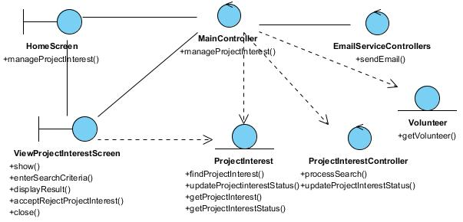
Figure 2 - Class Diagram

:

Derived Requirements
This project manager’s PC keyboard or mouse will be used to select/update required criteria and view all the system responses.

ANNEX D Amendment History

This is a record of all amendments made to the Document.
Version | Chapter / Section | Page No | Notes of Amendments or Changes

